
Mathematics Specialist
Test 4 2017

Integration Techniques &
Applications of Integral Calculus

NAME: _______SOLUTIONS_____________________ TEACHER: Mrs Da Cruz

Resource Free Section

33 marks
35 minutes

Question 1 [3 & 3 = 6 marks]
- Express as partial fractions.
$$\frac{2}{x^{2}-1}=\frac{A}{x-1}+\frac{B}{x+1}$$
$$∴2=A\left(x+1\right)+B(x-1)$$
$$∴\left\{\begin{matrix}2=A-B \\ 0=A+B\end{matrix}\right.⟹A=1,B=-1$$
$$∴\frac{2}{x^{2}-1}=\frac{1}{x-1}-\frac{1}{x+1}$$

- Hence determine $\int_{2}^{8}{\frac{2}{x^{2}-1}dx}.$ Simplify your answer to the form $\ln{\frac{p}{q}}$.

$$\int_{2}^{8}{\frac{2}{x^{2}-1}}dx=\int_{2}^{8}{\frac{1}{x-1}-\frac{1}{x+1}dx}$$
$$={\left[\ln\left(x-1\right)-\ln\left(x+1\right)\right]}_{2}^{8}$$
$$=\ln{7}-\ln{9}-\ln{1}+\ln{3}$$
$$=\ln{\frac{7×3}{9}}$$
$$=\ln{\frac{7}{3}}$$

Question 2 [3, 2 & 2 = 7 marks]
Determine the following indefinite integrals:
(a) $\int{1-\cos^{2}{(5x)} dx}$
$$\int{1-\cos^{2}\left(5x\right) dx}=\int{\sin^{2}\left(5x\right)dx}$$
$$=\int{\frac{1}{2}\left(1-\cos\left(10x\right)\right)dx}$$
$$=\frac{1}{2}\left(x-\frac{\sin{(10x)}}{10}\right)+c$$
$$=\frac{x}{2}-\frac{\sin\left(10x\right)}{20}+c$$

-

(b) $\int{\frac{1}{2}\left(2x-4\right){\left(x^{2}-4x+1\right)}^{6}dx}$
$$\frac{1}{2}\int{\left(2x-4\right){\left(x^{2}-4x+1\right)}^{6} dx}$$
$$=\frac{1}{2}\frac{{\left(x^{2}-4x+1\right)}^{7}}{7}+c$$
$$=\frac{{\left(x^{2}-4x+1\right)}^{7}}{14}+c$$

(c) $\int{\sin^{3}\left(2x\right)\cos{(2x)} dx}$

$$\frac{1}{2}\int{{\left[\sin\left(2x\right)\right]}^{3}\cos\left(2x\right).2 dx}$$
$$=\frac{1}{2}\frac{{\left[\sin\left(2x\right)\right]}^{4}}{4}+c$$
$$=\frac{\sin^{4}{(2x)}}{8}+c$$

Question 3 [5 marks]
Use the substitution $u=4+\sqrt{x}$ to evaluate $\int{\sqrt{4+\sqrt{x}} dx}$.
Do not factorize your answer. Do not leave any fractional or negative indices.

$$\frac{du}{dx}=\frac{1}{2}x^{-\frac{1}{2}}=\frac{1}{2\sqrt{x}}$$
$$du 2\sqrt{x}=dx$$
$$du 2\left(u-4\right)=dx$$
$$∴\int{\sqrt{4+\sqrt{x}} dx}=\int{\sqrt{u} 2\left(u-4\right)du}$$
$$=2\int{u^{\frac{3}{2}}-4u^{\frac{1}{2}} du}$$
$$=2\left(\frac{{2u}^{\frac{5}{2}}}{5}-\frac{8u^{\frac{3}{2}}}{3}\right)+c$$
$$=\frac{4{\sqrt{u}}^{5}}{5}-\frac{16{\sqrt{u}}^{3}}{3}+c$$

$$=\frac{4{\sqrt{4+\sqrt{x}}}^{5}}{5}-\frac{16{\sqrt{4+\sqrt{x}}}^{3}}{3}+c$$

Question 4 [1 mark]

The area under the curve y = k(x) can be described by:
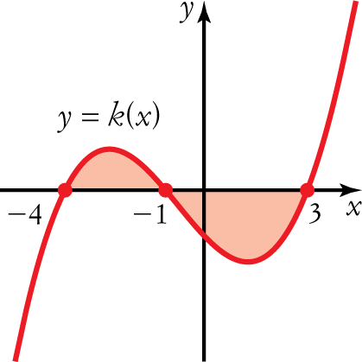
A
B
C
D
E

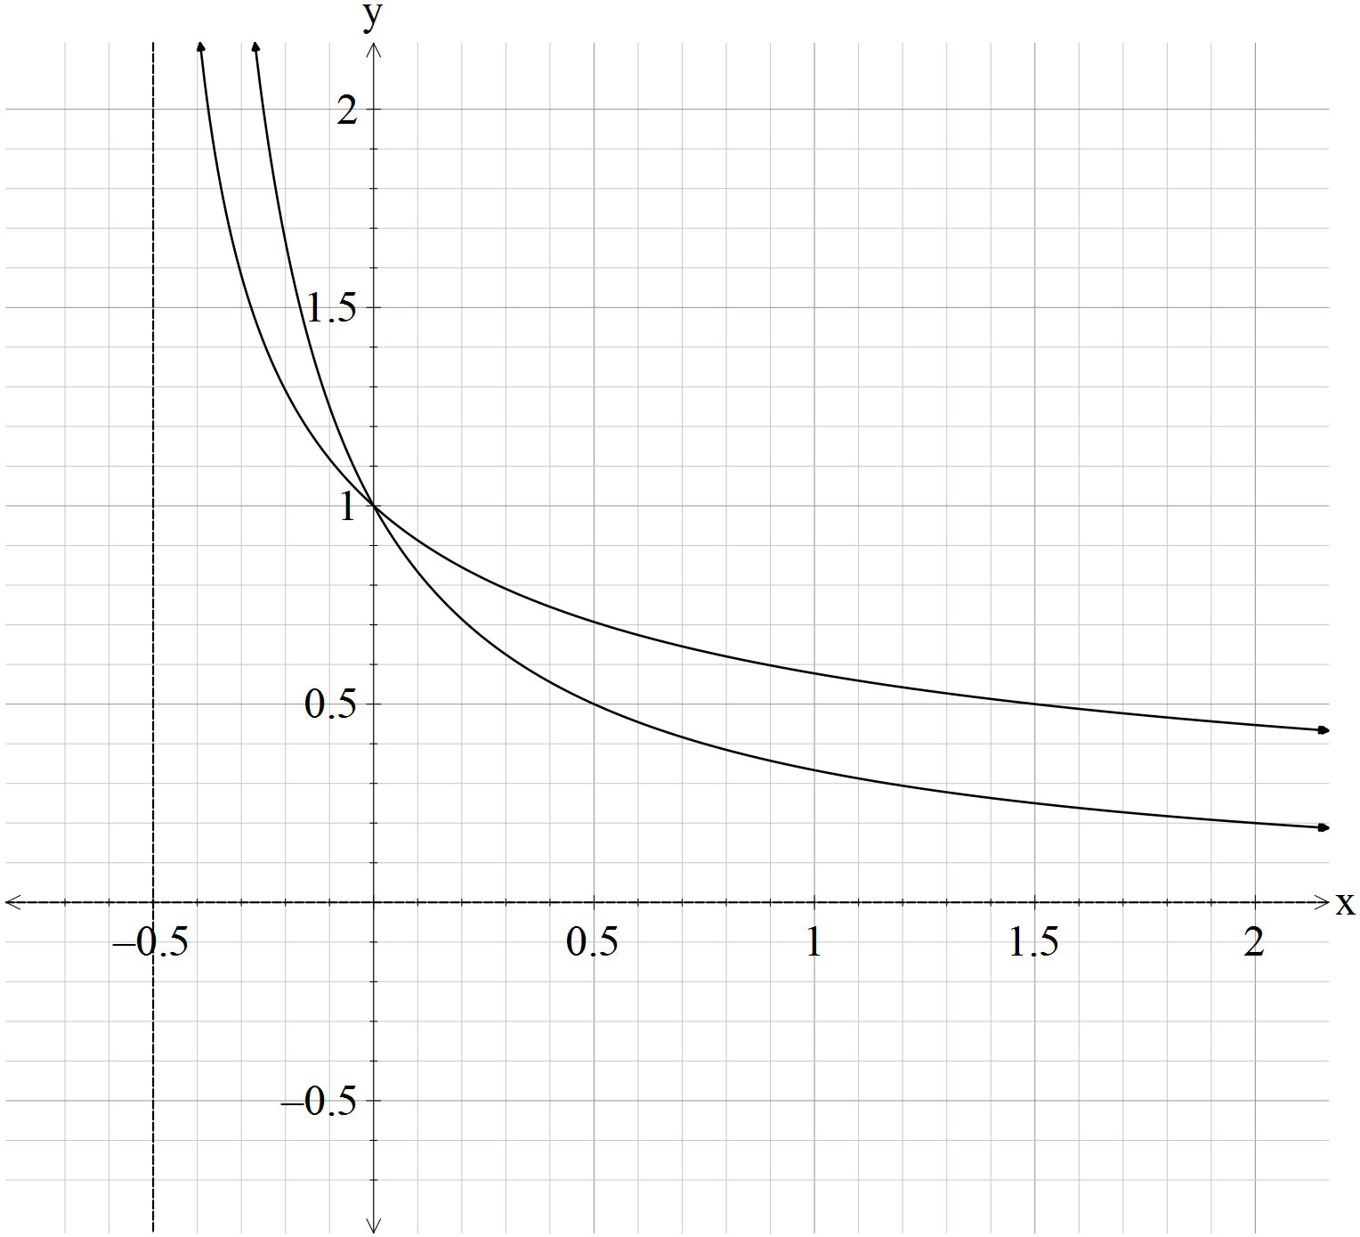Question 5 [3 & 4 = 7 marks]

$$g(x)$$
$$f(x)$$

- Find the area under the curve, in square units, for the function $f(x)=\frac{1}{2x+1}$ from $x=0$ to $x=1.$
$$A=\int_{0}^{1}{\frac{1}{2x+1}dx}=\frac{1}{2}\int_{0}^{1}{\frac{2}{2x+1}dx}$$
$$=\frac{1}{2}{\left[\ln{(2x+1}\right]}_{0}^{1}$$
$$=\frac{1}{2}\left(\ln{3}-ln1\right)=\frac{\ln{3}}{2} units^{2}$$

- Find the area enclosed by the curves, in square units, of the graphs $f(x)=\frac{1}{2x+1}$ ,
$g(x)=\frac{1}{\sqrt{2x+1}}$and the line $x=1.$
$$A=\int_{0}^{1}{\frac{1}{\sqrt{2x+1}}-\frac{1}{2x+1}dx}$$
$$={\left[{\left(2x+1\right)}^{\frac{1}{2}}-\frac{\ln{(2x+1)}}{2}\right]}_{0}^{1}$$
$$=\left[\sqrt{3}-\frac{\ln{3}}{2}-(\sqrt{1}-\frac{\ln{1}}{2})\right]$$
$$=\sqrt{3}-\frac{\ln{3}}{2}-1 units^{2}$$

Question 6 [2 marks]
Find $\frac{d}{dx}\left(x^{2}e^{x}\right)$ and use your answer to evaluate $\int{4xe^{x}\left(x+2\right)dx}.$
$$\frac{dy}{dx}=2x.e^{x}+e^{x}.x^{2}=x.e^{x}(2+x)$$
$$\int{4x.e^{x}(2+x)dx}=4\int{x.e^{x}\left(2+x\right)dx=4x^{2}e^{x}}+c$$

Question 7 [5 marks]
The region bounded by the lines $x=k$ and $x=1$ and the curve $y^{2}=4x^{3}-4x$ is rotated about the
x-axis 180$°$. The volume formed is $9π$. Determine the value of $k$ where $k$ is a positive integer.
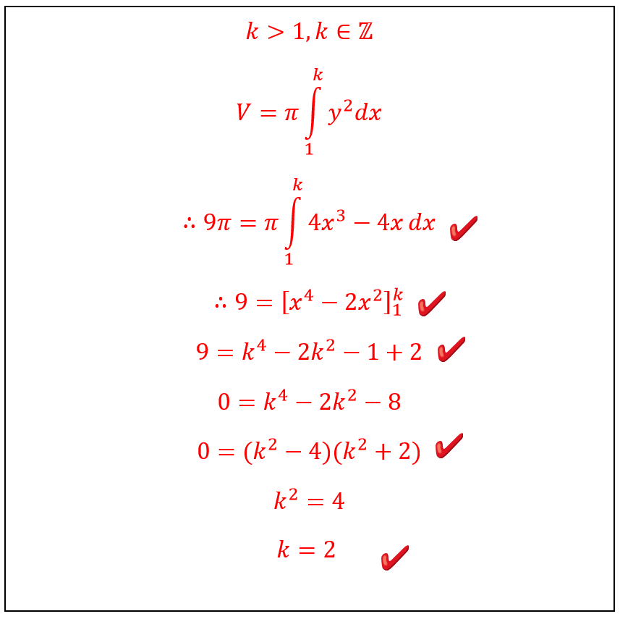
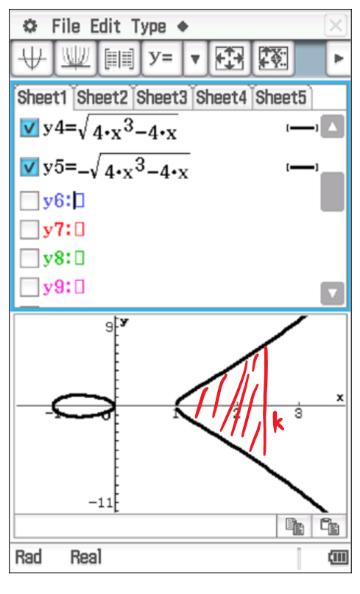
Rotating the shaded area 180$°$ is the same as rotating the top half 360$°$.

Mathematics Specialist
Test 4 2017

Integration Techniques &
Applications of Integral Calculus

NAME: __________SOLUTIONS___________________ TEACHER: Mrs Da Cruz

Resource Rich Section

11 marks
15 minutes

One unfolded A4 page of notes, SCSA formulae booklet and ClassPad calculator permitted

Question 8 [1, 1 & 2 = 4 marks]
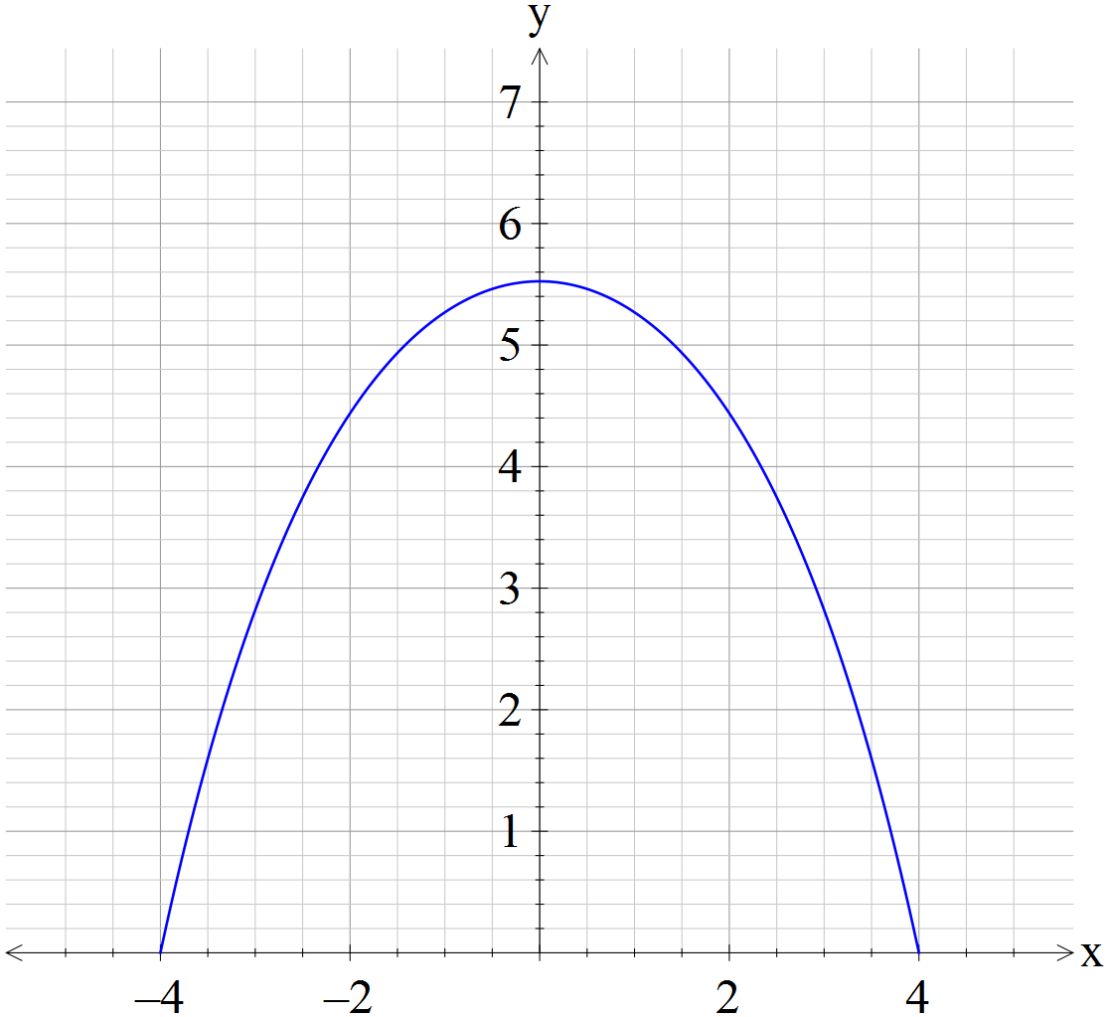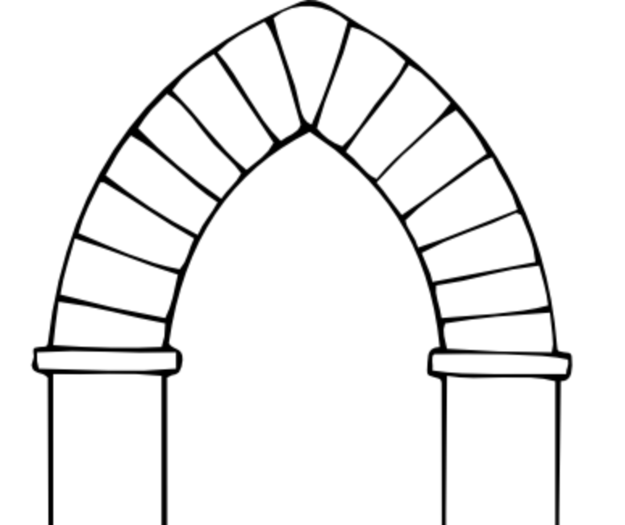

The upper component of an archway is designed to bear the load of the wall above and around it. For this, the best shape is a catenary. A catenary is the name given to the curve formed by two simple exponential terms added together. The equation of the upper arch is .
The x-intercepts of the catenary are (−4, 0) and (4, 0).
a Use this information to determine the exact value of c.

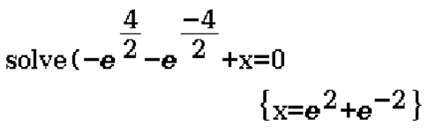
$$c=e^{2}+\frac{1}{e^{2}}$$

Paint has to be applied to the area under the catenary curve.
b State a definite integral that will find the area of paint required.
$$A=\int_{-4}^{4}{-e^{\frac{x}{2}}-e^{-\frac{x}{2}}+e^{2}+\frac{1}{e^{2}}dx}$$

c Calculate the exact area to be painted, giving your answer with positive indices.
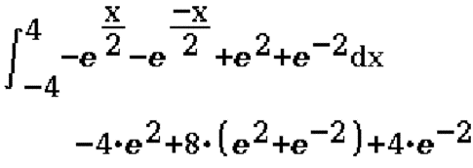
$$A={\left[-2e^{\frac{x}{2}}+2e^{-\frac{x}{2}}+{xe}^{2}+\frac{x}{e^{2}}\right]}_{-4}^{4}$$
$$A=4e^{2}+\frac{12}{e^{2}} units^{2}$$

-1 if answer not simplified

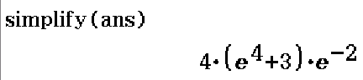

Question 9 [2 marks]
Use a suitable definite integral to find the exact volume, in cubic units, that is formed by rotating about the x-axis the following curves between the limits shown.
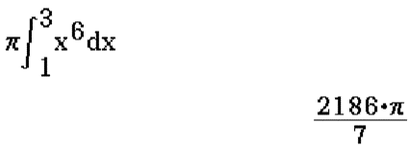
y = $x^{3}$, from x = 1 and x = 3.

$$V=π\int_{1}^{3}{x^{6}dx}$$
$$=\frac{2186π}{7} units^{3}$$

Question 10 [3 marks]

Use a suitable definite integral to find the exact volume, in cubic units, that is formed by rotating about the y-axis the following curves between the limits shown.
, from y = 0 and y = 1.

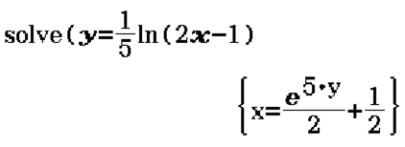
$$V=π\int_{0}^{1}{x^{2}dy}$$
$$∴V=π\int_{0}^{1}{{\left(\frac{e^{5y}}{2}+\frac{1}{2}\right)}^{2}dy}$$
$$=π\left(\frac{e^{10}}{40}+\frac{e^{5}}{10}+\frac{1}{8}\right) units^{3}$$
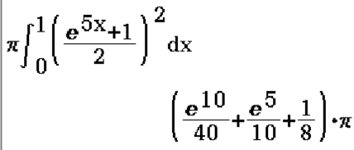
Question 10 [2 marks]

Use a suitable definite integral to find the exact volume, in cubic units, that is formed by rotating the shaded area about the y-axis.
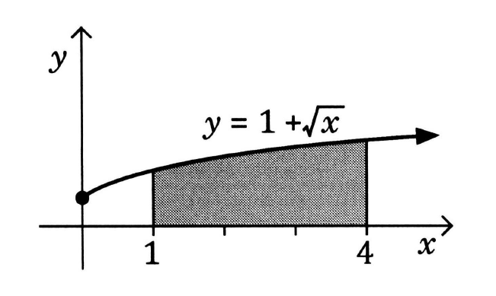
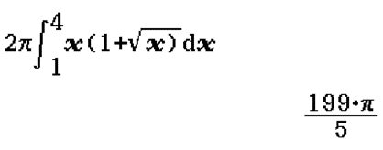
$$V=2π\int_{1}^{4}{xydx}$$
$$=2π\int_{1}^{4}{x\left(1+\sqrt{x}\right)dx}$$
$$=\frac{199π}{5}units^{3}$$

